Alert Triage with Threat Intelligence Report
Objective
The objective of this exercise was to perform alert triage using threat intelligence sources to validate indicators of compromise (IOCs), prioritize security alerts, and support effective incident response. The activity focused on analyzing security alerts, assessing their severity, and enriching them with information obtained from threat intelligence platforms.
Tools Used
- Wazuh
- VirusTotal
- AlienVault OTX
- Google Sheets / Excel
Introduction
Alert triage is one of the primary responsibilities of a Security Operations Center (SOC) analyst. The process involves reviewing security alerts, determining their legitimacy, assigning priority levels, and deciding whether escalation or further investigation is required.
Threat intelligence enhances alert triage by providing contextual information about IP addresses, domains, file hashes, and attacker infrastructure. This additional information helps analysts distinguish between false positives and genuine threats.
Alert Analysis
A simulated alert was generated for suspicious PowerShell execution on a monitored system.
Alert Details
The alert was initially classified as High Priority due to the potential use of PowerShell for malicious activities such as privilege escalation, lateral movement, or malware execution.
Triage Process
The following steps were performed during alert triage:
Step 1: Alert Review
The alert details were examined to understand the nature of the event and identify the affected system.
Step 2: IOC Extraction
Relevant indicators were extracted from the alert, including:
- Source IP Address
- Process Name
- Timestamp
- Related Network Activity
Step 3: Threat Intelligence Validation
The extracted indicators were validated using external threat intelligence sources.
VirusTotal Check
The source IP and related indicators were checked against VirusTotal to determine whether they had been previously associated with malicious activity.
AlienVault OTX Check
The indicators were also compared against AlienVault OTX threat intelligence feeds to identify any known associations with malicious campaigns or attacker infrastructure.
IOC Validation Results
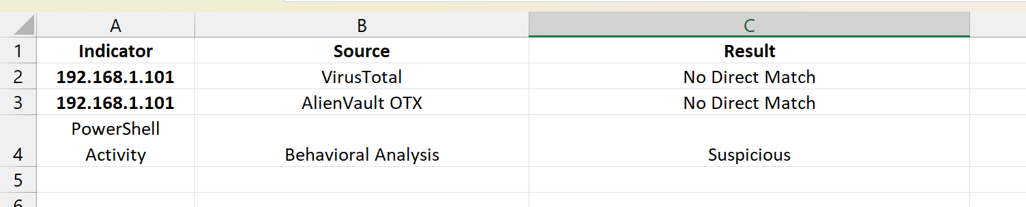
The intelligence sources did not identify the IP address as known malicious. However, the observed PowerShell behaviour remained suspicious and warranted additional monitoring.
Findings
The investigation identified several factors that increased the alert's significance:
- PowerShell execution occurred unexpectedly.
- The activity was inconsistent with normal user behavior.
- Associated network connections required additional review.
- Threat intelligence validation provided supporting context.
Although no confirmed malicious IOC was identified, the alert remained open pending further investigation.
Benefits of Threat Intelligence in Triage
Threat intelligence significantly improved the triage process by:
- Providing context for indicators.
- Assisting with risk assessment.
- Reducing false positives.
- Improving analyst decision-making.
- Supporting prioritization of security events.
The use of external intelligence sources enabled analysts to make more informed decisions regarding alert severity and response actions.
Results
The alert triage process was completed successfully. The alert was reviewed, validated against threat intelligence sources, and prioritized based on risk and observed behavior.
Key outcomes included:
- Successful IOC extraction.
- Threat intelligence validation completed.
- Alert severity confirmed.
- Investigation documentation created.
- Alert retained for continued monitoring.
Conclusion
Alert triage is a fundamental SOC activity that helps organizations identify and respond to potential security threats efficiently. The integration of threat intelligence into the triage process enhances visibility, improves decision-making, and enables analysts to prioritize incidents more effectively.
This exercise demonstrated how threat intelligence platforms such as VirusTotal and AlienVault OTX can support alert investigation and validation. The objectives of the exercise were successfully achieved, and the alert was appropriately analyzed and documented for future follow-up.

